1. Design a home page which will display your information i.e. Bio data.

2. Create Hyperlinks in home page i.e educational details, Hobbies,

Achievement, My Ideals etc.

3. Design a timetable and display it in tabular format.

4. Design a Registration form in HTML.

6. Design webpage using Frames,Framesets.

**Exercise No 1: – Practical 1**

**Aim: - Design a home page which will display your information i.e. Bio data.**

**Tools: Notepad Editor and Web Browser like Internet Explorer or Mozilla Firefox.**

Standard Procedure for Creating and View an HTML document?

**1. Use a text editor such as Notepad to write the document.**

**2. Save the file as filename.html on a PC. This is called the Document Source.**

**3. Open the file that you have saved in any browser Off-Line.**

**4. Your HTML page should now appear just like any other Web page in browser.**

**5. You may now switch back and forth between the Source and the HTML**

**Document**

• switch to Notepad with the Document Source

• make changes.

• save the document again.

• switch back to browser.

• click on RELOAD and view the new HTML Document.

• switch to Notepad with the Document Source.

**THEORY:**

**1. What is HTML?**

• A series of tags that are integrated into a text document.

• A series of tags that are integrated into a text document.

• These look like: <code>formatted text</code>

o <code> begins the formatting tag.

o </code> ends the formatting tag.

• These tags are then read by a Browser, which translates the tags into the formatting that they represent

**2. What are Tags?**

• HTML tags are used to mark-up HTML elements.

• HTML tags are surrounded by the two characters < and >.

• The surrounding characters are called angle brackets .

• HTML tags normally come in pairs like <b> and </b>.

• The first tag in a pair is the start tag, the second tag is the end tag.

• The text between the start and end tags is the element content .

• HTML tags are not case sensitive, <b> means the same as <B>.

**3. Structure Tags In HTML**

**HTML Tag**

<HTML></HTML>

These tags begin and end an HTML document.

**HEAD Tag**

<HEAD></HEAD>

These tags are in the beginning of the document. Important information is stored in- between these tags including: title, meta-data, styles, and programming scripts.

**TITLE Tag**

<TITLE></TITLE>

These tags are in-between the HEAD tags and contain the text that appears in the title of the Web page.

**BODY Tag**

<BODY></BODY>

As you may have guessed, the BODY tags contain all the text in the body of the document.

**4. Block Level tags**

**4.1 HTML Headings –**

Headings are defined with the<h1> to<h6> tags.

Where <h1> -Defines the largest headings.

<h6> -Defines the smallest headings.

**4.2 HTML Paragraphs -**

Paragraphs are defined with the<p> tag.

**4.3 HTML Line Breaks -**

Use the <br/> tag if you want a line break (a new line) without starting a new paragraph.

**4.4 Horizontal Rule**

The <hr> element is used for horizontal rules that act as dividers between sections

**5. HTML Text Formatting Tags**

Tag Description

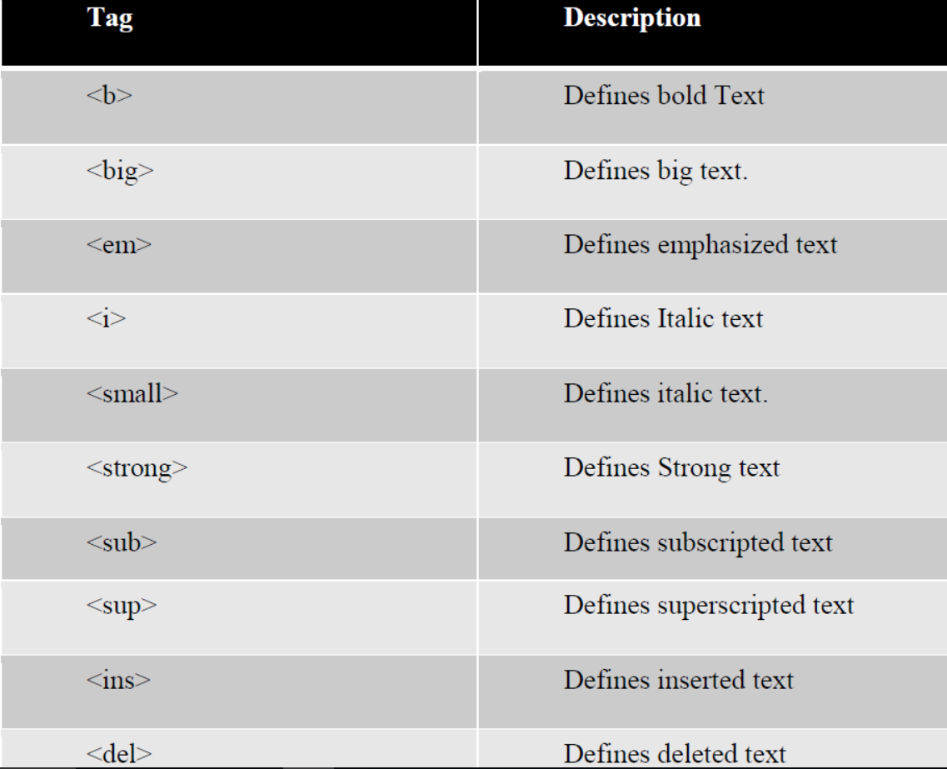

**CONCLUSIONS:**

In this way we can use different basic tags of HTML for creating webpage

displaying personal information i.e. Biodata.

**Aim: - Create Hyperlinks in home page i.e. educational details, Hobbies,**

**Achievement, My Ideals etc.**

**Tools:** Notepad Editor and Web Browser like Internet Explorer or Mozilla Firefox.

**STANDARD PROCEDURE:**

• Step 1: Create **Educational_Details.html** page.

• Step 2: Create **Hobbies.html** page.

• Step 3: Create **Achievements.html** page.

• Step 4: Create **My_Ideals.html** page.

• Step 5: Create links of above four html pages in **Link.html** page.

**THEORY:**

HTML uses the <a> anchor tag to create a link to another document or web page.

**The Anchor Tag and the Href Attribute**

• An anchor can point to any resource on the Web: an HTML page, an image, a sound file, a movie, etc. The syntax of creating an anchor:

• <a href="url">Text to be displayed</a>

• The <a> tag is used to create an anchor to link from, the href attribute is used to tell the address of the document or page we are linking to, and the words between the open and close of the anchor tag will be displayed as a hyperlink.

**The Target Attribute**

• With the target attribute, you can define **where** the linked document will be

opened. By default, the link will open in the current window.

• The code below will open the document in a new browser window. <a href=http://www. google.com/ target="_blank">Visit google!</a>

**Email Links**

• To create an email link, you will use mailto: plus your email address. Here is a link to ACC's Help Desk:

<a href="mailto:helpdesk@abc.com">Email Help Desk</a>

• To add a subject for the email message, you would add ?subject= after the

email address. For example:

<a href="mailto:helpdesk@abc.com?subject=Email Assistance">Email Help

Desk</a>

**CONCLUSIONS:**

With the help of given procedure and information about the Links we can write

HTML code for creating Hyperlinks in html page.

**Aim: - Design a timetable and display it in tabular format.**

**Tools:** Notepad Editor and Web Browser like Internet Explorer or Mozilla Firefox.

**THEORY:**

**HTML Tables:**

• Tables are defined with the <table> tag.

• A table is divided into rows (with the <tr> tag),

• Each row is divided into data cells (with the <td> tag).

• td stands for "table data," and holds the content of a data cell.

• A <td> tag can contain text, links, images, lists, forms, other tables, etc.

**HTML Tables and the Border Attribute**

If you do not specify a border attribute, the table will be displayed without borders.

Sometimes this can be useful, but most of the time, we want the borders to show.

**To Create Table Header**

<html>

<body>

<h4>Table headers:</h4>

<table border="1">

<tr>

<th>Name</th>

<th>Telephone</th>

<th>Telephone</th>

</tr>

<tr>

<td>Bill Gates</td>

<td>555 77 854</td>

<td>555 77 855</td>

</tr>

</table>

</body>

</html>

Output

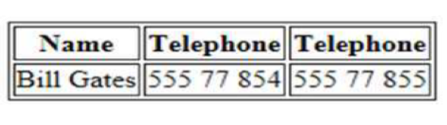

**How to add a caption to a table.**

**<caption>Monthly savings</caption>**

**Table Cells then spans more then one row/column**

For Example-

<html>

<body>

<h4>Cell that spans two columns:</h4>

<table border="1">

<tr>

<th>Name</th>

<th colspan="2">Telephone</th>

</tr>

<tr>

<td>Bill Gates</td>

<td>555 77 854</td>

<td>555 77 855</td>

</tr>

</table>

<h4>Cell that spans two rows:</h4>

<table border="1">

<tr> <th>First Name:</th>

<td>Bill Gates</td>

</tr>

<tr>

<th rowspan="2">Telephone:</th>

<td>555 77 854</td>

</tr>

<tr>

<td>555 77 855

</td>

</tr>

</table></body></html>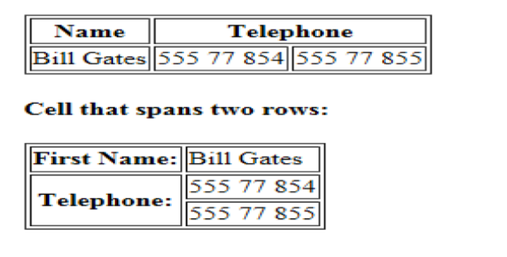

**Output-**

**CONCLUSIONS:**

With the help of given information about the Table and Table tags we can design a

time table in tabular format.

**Aim: - Design a Registration form in HTML.**

**Tools:** Notepad Editor and Web Browser like Internet Explorer or Mozilla Firefox.

**THEORY:**

• HTML Forms are used to select different kinds of user input.

• A form is an area that can contain form elements.

• Form Elements are elements that allow the user to enter information Like

a. Text Fields

b. Text area Fields

c. drop-down Menus

d. Radio buttons

e. Checkboxes

A Form is defined with <form> tag.

**Input Tag**

• The most used form tag is the <input> tag. The type of input is specified

with the type attribute.

For Creating Textbox: <input type=“text”>

For Creating Password textbox: <input type=‘’password’’>

For Creating Radio button: <input type = "radio">

For Creating Checkbox: <input type = "checkbox">

For Creating Buttons: <input type ="button" value= "OK" />

For Creating Reset Button: <input type ="reset" value= "Reset" />

For Creating Submit Button: <input type ="Submit" value= "Submit" />

**Dropdown list:**

**1. SELECT tag** - Defines the controls for selection of options and

creates a dropdown list.

10

**2. OPTION tag** - Defines an options in a drop-down list , its most

important attribute is the VALUE attribute that determines the value

being sent to the server.

**3. OPTGROUP tag** - Allows you to group your choices in the form.

**For Example-**

<form>

<select >

<optgroup label = " Generel Hobby" >

<option value= "playing" > Playing </option>

<option value = "watching movies" > Watching Movies </option>

</optgroup>

<optgroup label = "Educational Hobby">

<option value = "reading" > Reading </option>

<option value ="stamp collection" >Stamp Collection </option>

</optgroup>

</select>

</form>

Output-

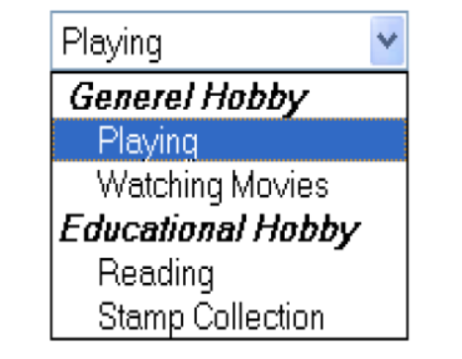

**1. SELECT tag** - Defines the controls for selection of options and

creates a dropdown list.

**2. OPTION tag** - Defines an options in a drop-down list , its most

important attribute is the VALUE attribute that determines the value

being sent to the server.

**3. OPTGROUP tag** - Allows you to group your choices in the form.

• **Textarea**:

**For Example**11

<form>

<textarea rows = "10" cols = "30" >

this is an example of textarea , a user can input a text in this area

</textarea>

</form>

Output-

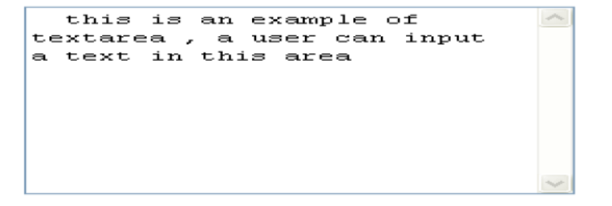

**CONCLUSIONS:**

With the help of given information, we can design a Registration form by suing

form tag and attributes.

**Aim: - Design webpage displaying different subject information using**

**Frames, Framesets.**

**Tools:** Notepad Editor and Web Browser like Internet Explorer or Mozilla Firefox.

**STANDARD PROCEDURE:**

• Step 1: Create **subject1.html** page.

• Step 2: Create **subject2.html** page.

• Step 3: Create **subject3.html** page.

• Step 4: Create a page having multiple frames of above subjects.

**THEORY:**

• With Frames, you can display more than one HTML document in the same

browser window.

• Each HTML document is called a frame.

• Each frame is independent of Each Other.

**The Frameset Tag-**

• The <frameset> tag defines how to divide the window into frames**.**

• Each Frameset Defines a set of rows or columns.

• The values of rows/columns indicate the amount of screen area each

row/column will occupy.

• The frameset column size value can also be set in pixels (cols=“200,500”),

• and one of the columns can be set to use the remaining space

(cols=“25%,*”)

**The Frame Tag-**

The <frame> tag defines what HTML document to put into each frame.

**In the following example**

• We have frameset with two columns.

• The first column is set to 25% of the width of the browser window.

16

• The second column is set to 75% of the width of the browser window.

• The HTML document “frame1.html” is put into first column and

• The HTML document “Frame2.html” is put into the second column.

<html>

<frameset cols = "40% , 60%">

<frame src = "frame1.html ">

<frame src = "frame2.html ">

</frameset>

</html>

**Noresize Attribute in Frame Tag-**

• If a frame has visible borders, the user can resize it by dragging the border.

• To prevent a user from doing this, you can add noresize=“noresize” to the

<frame> tag.

**Iframe Tag-**

• Defines an inline sub window (frame).

**For Example-**

<html>

<iframe src="frame1.html"></iframe><br>

<iframe src="frame2.html"></iframe>

</html>

**CONCLUSIONS:**

With the help of given procedure and information about the Frame we design a

webpage having multiple frames view for displaying subject information.